Word Norms Web Guide

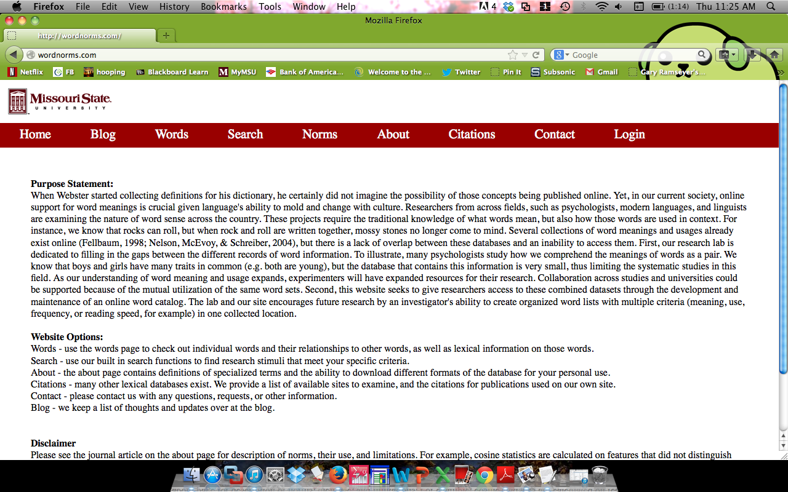

The website has several basic components:

* Words - use the words page to check out individual words and their relationships to other words, as well as lexical information on those words.
* Search - use our built in search functions to find research stimuli that meet your specific criteria.
* Norms - look at the LAB: Linguistic Annotated Bibliography to search for specific types of linguistic data.
* About - the about page contains definitions of specialized terms and the ability to download different formats of the database for your personal use.
* Citations - many other lexical databases exist. We provide a list of available sites to examine, and the citations for publications used on our own site.
* Contact - please contact us with any questions, requests, or other information.
* Blog - we keep a list of thoughts and updates over at the blog.

# Words

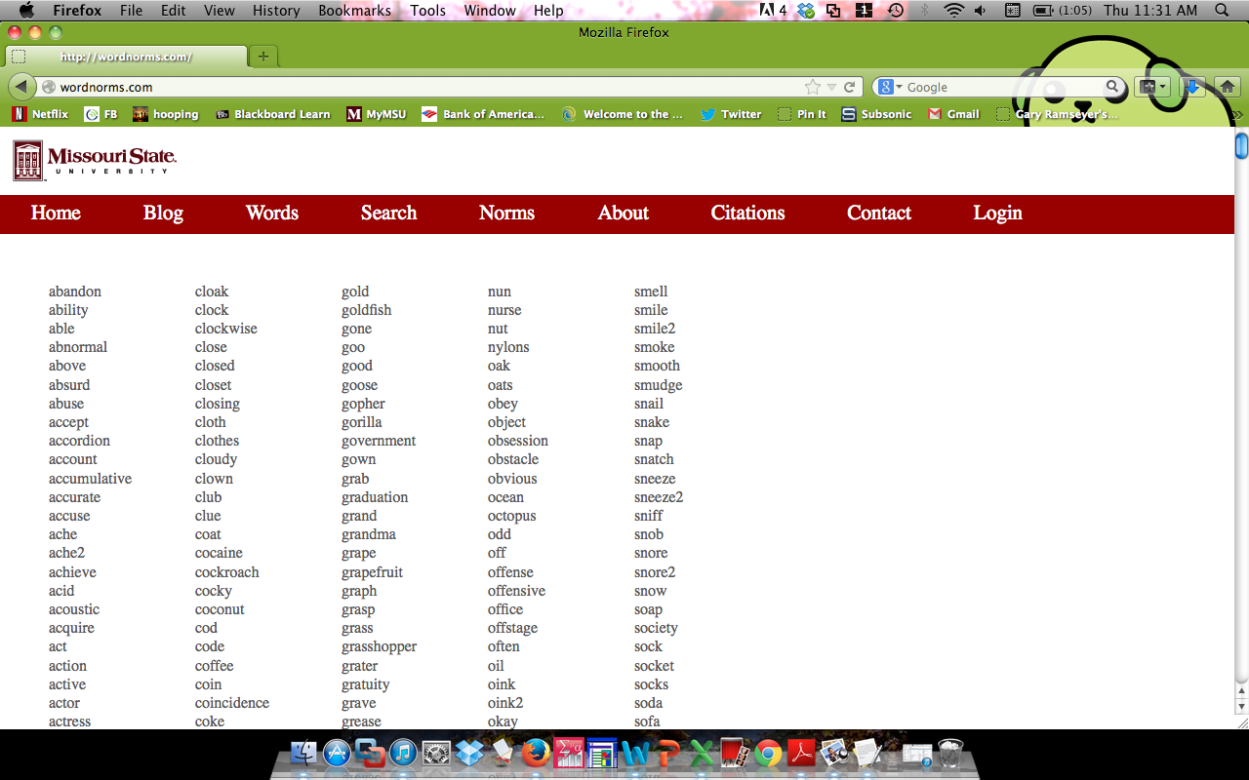

When you click on the words link, you will find a list of all the words contained in the database. Each word is clickable, which will bring up the related information for that word. Words with underscores (\_) or numbers (2) indicate a different sense of the noun/verb, as explained in McRae et al. (2005) or Vinson and Vigliocco (2008).

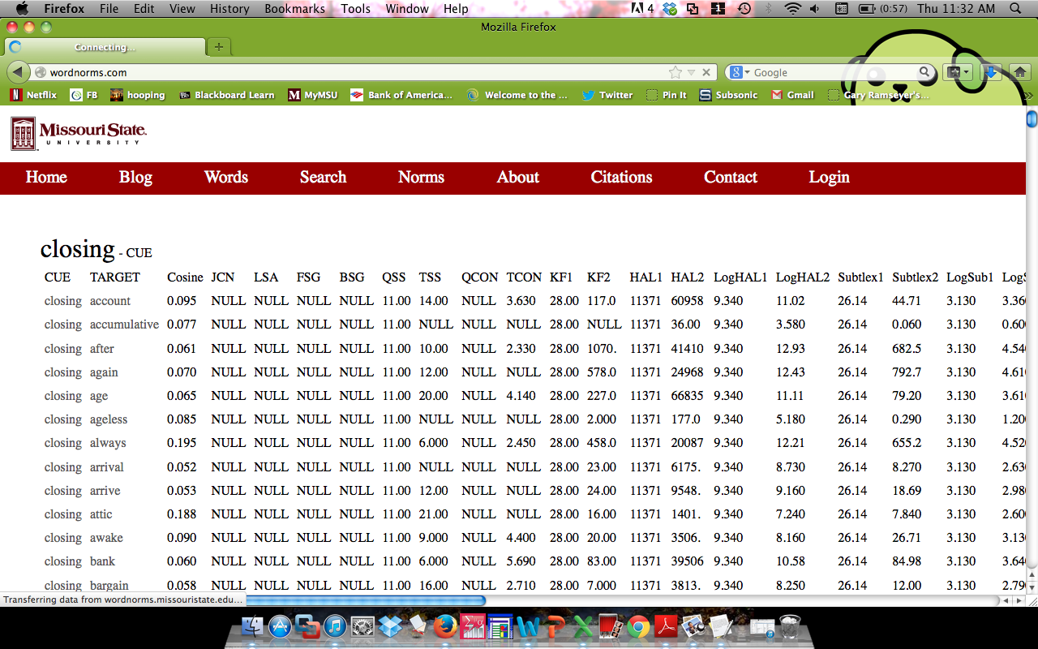

Here, we have selected the word “closing”. The top section of each individual word page is where the concept is the CUE (i.e. first word) in a cue-target pair. Each related word with closing is presented (indicating nonzero relationships for cosine, JCN, or FSG). You can click on the target of each pair to pull up words related to those targets (potentially useful for mediated pairs).

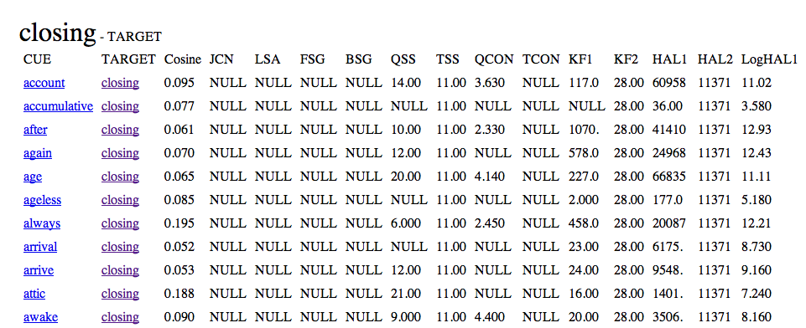

Down the page, you will find the pairs were closing is the TARGET word (i.e. second word) in a pairing. Mainly, this distinction affects the FSG and BSG variables that are order specific.

You can highlight the cells to cut and paste database information into Excel or SPSS. Variable names are explained in the variable list document available on the About page.

# Search

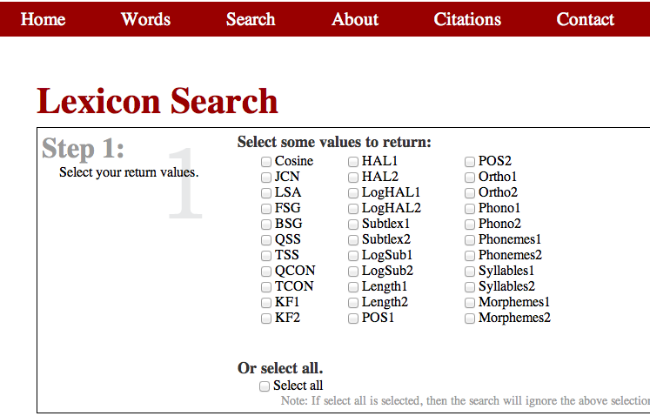

The first step on the search page is to select which values you would like to find. You can select all variables or only those that you are interested in. The 1 and 2 markers denote the (1) first word and (2) second word in a cue-target pair. For instance, KF1 will return the Kucera and Francis’ word frequency norms for the first word in each pair. If you are interested in individual word norms, you might also find Balota et al.’s English Lexicon Project a good search portal for single word information (link is on citations page).

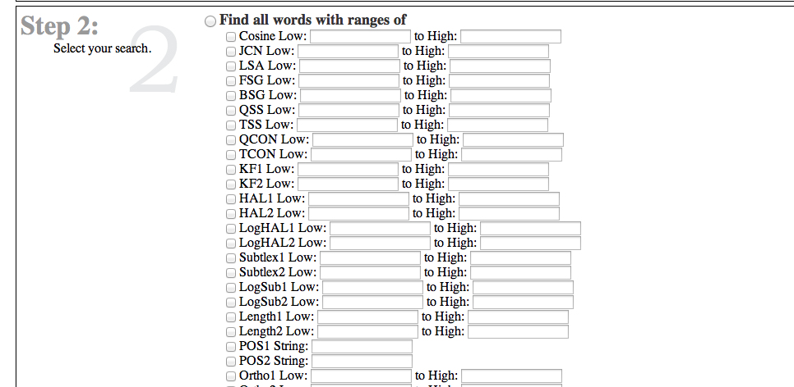

Second, you can select ranges for target pairs. Again, variables are explained in the variable list word document on the about page. This table also includes all the minimum, maximum and string values to search for (i.e. FSG ranges from 0.00 to approximately 0.90).

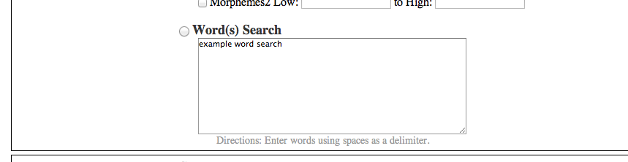

Another option would be to search for specific words. Type in your words here, and all values selected in step one will be shown (similar to the words page).

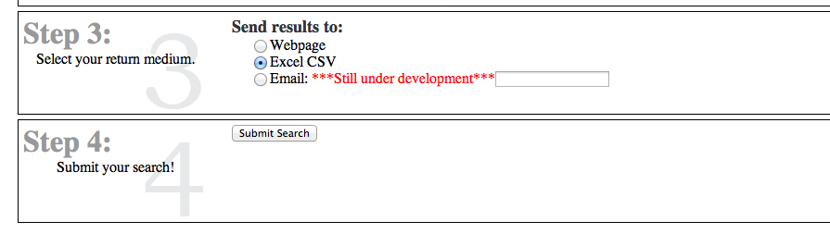

Lastly, you can select how you would like to receive the data. Webpage will send information to your browser for you to cut and paste, while CSV files are comma delimited for importing. The email function will email you the results (at the moment, results are a bit buggy. Please know that we are working on the functionality of emailing very large results).

# Norms

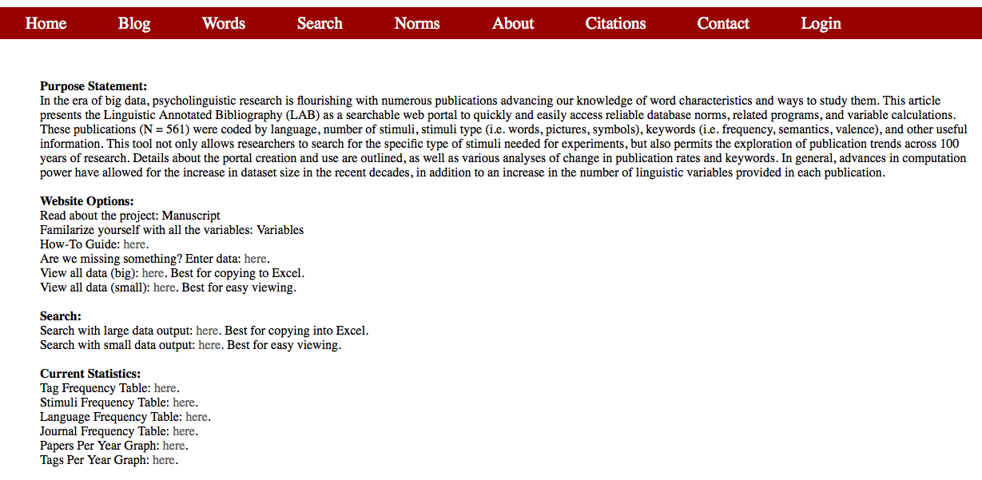

This page houses all of the information about the Linguistic Annotated Bibliography (LAB). From this page you can read our statement of purpose and manuscript and view the variables (all coming soon). You can also alert us to missing information, view the data, search the output, and view the current statistics about the LAB.



To enter missing data, click this link and you will be directed to the following page.

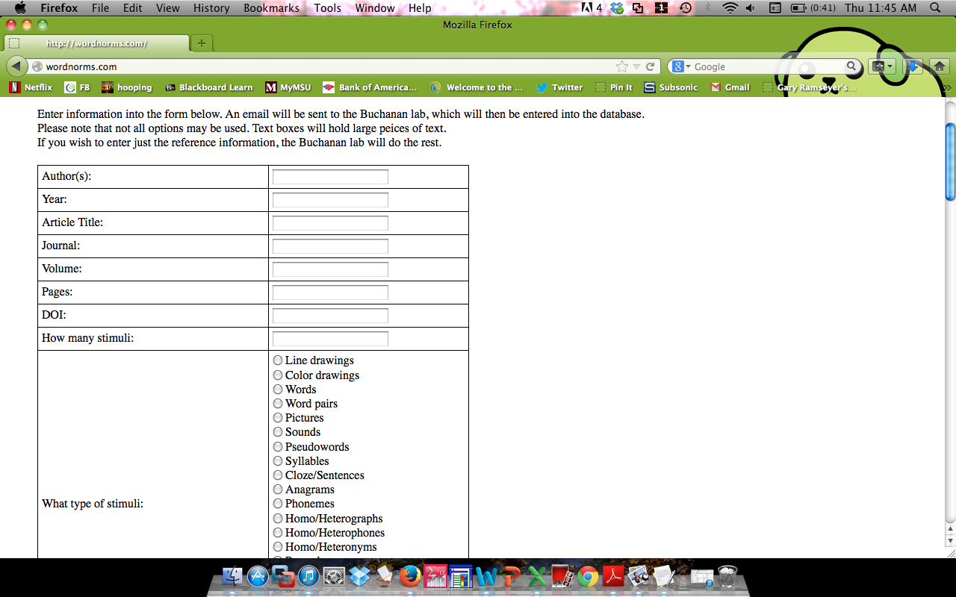

This page contains an interactive form that can be filled out in regard to any data we are missing. The information in the form will be sent to the Buchanan lab, which will then be checked and entered into the LAB. Please see the variable list or manuscript for descriptions of stimuli and keyword tags if they are unfamiliar to you.

Macintosh:Users:Katy:Desktop:Screen shot 2013-12-19 at 11.48.15 AM.png

There are to ways to view the LAB. The big data set contains all of the articles as well as their related expanded journal, stimuli, language, and tag information. This dataset is preferable for copying and pasting information into excel. The small dataset contains all of the articles as well as their related simplified references, stimuli, languages, tags, and notes. This dataset is preferable for quick and simple viewing. Both datasets contain links allowing you to report errors in the table.

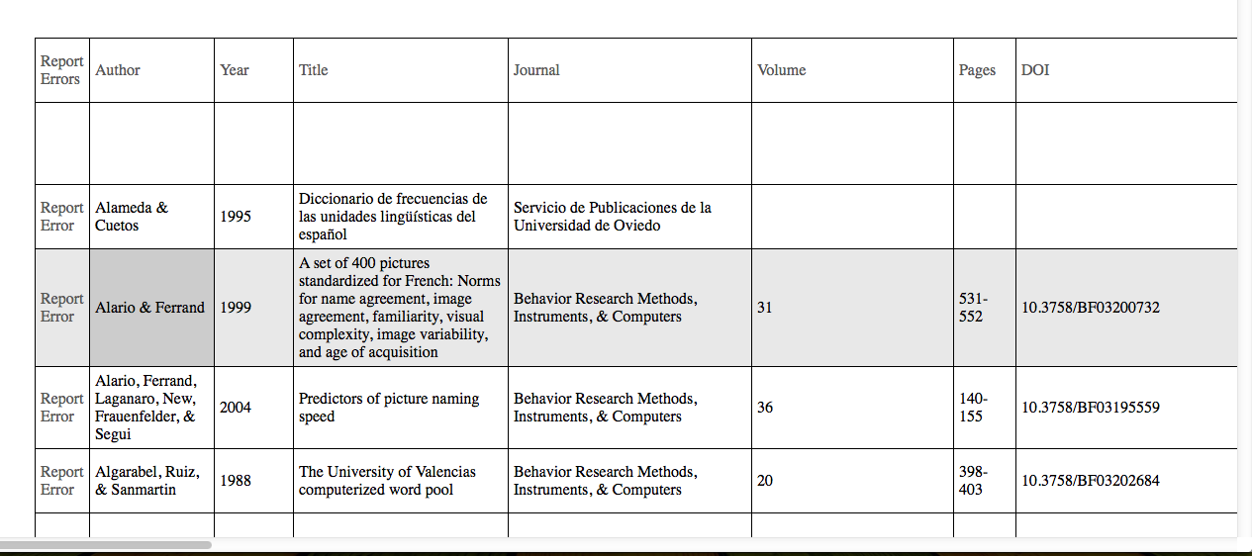

Large data output – columns are sortable by clicking on the column name.

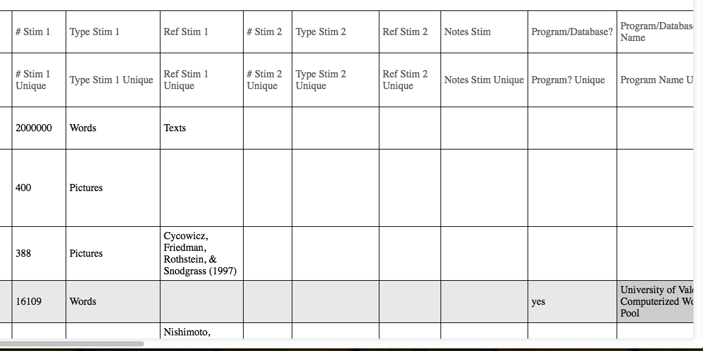

Large data output – clicking on the Unique links will display the table with rows that have data for that column. For example, the program/database column unique link will filter out all rows without that information.

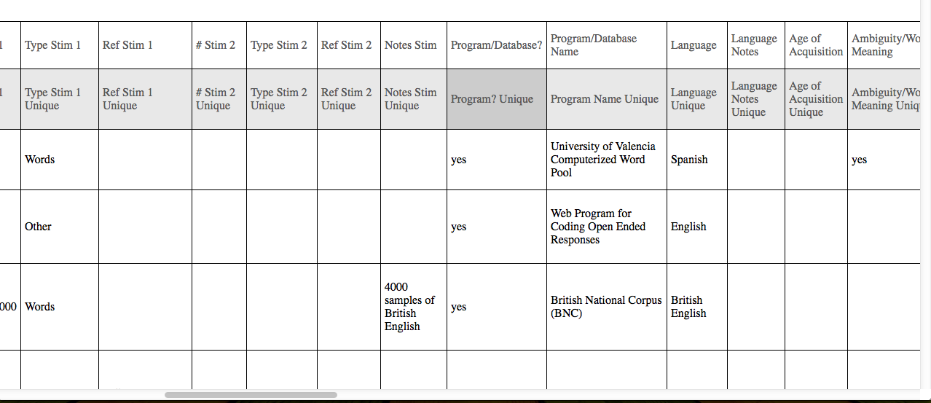

Large data output where the program? Unique link had been selected.

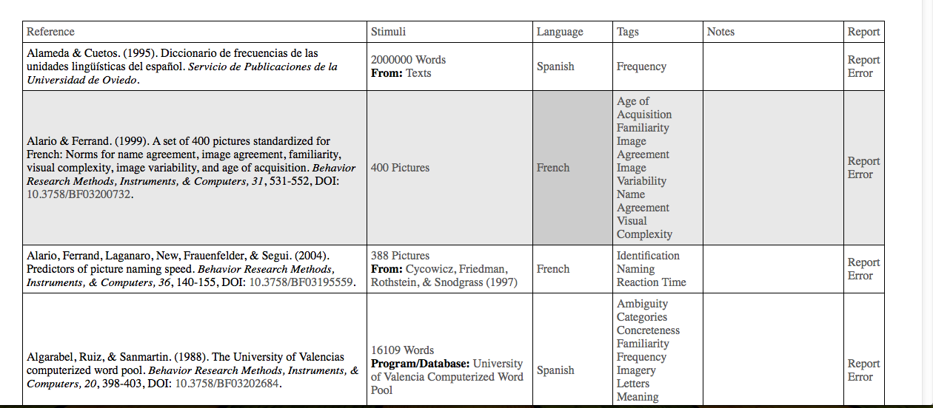

Small data output – the reference information is provided in APA format when possible (except for author first initials), the stimuli information is collapsed into one column, language, tags, notes (includes notes and special populations), and error reporting information. DOI links are clickable to take you to the publication website for that article (i.e. *Behavior Research Methods*). Clicking on tag names will show you rows with that specific tag (i.e. filters out rows without that tag).

To report an error, click the link adjacent to the article and a page will appear that has been prepopulated with the article’s information. Please enter the correct information or notes to alert us to the problem. Simply click the submit button at the bottom of the page and the Buchanan will then be able to fix the problem.

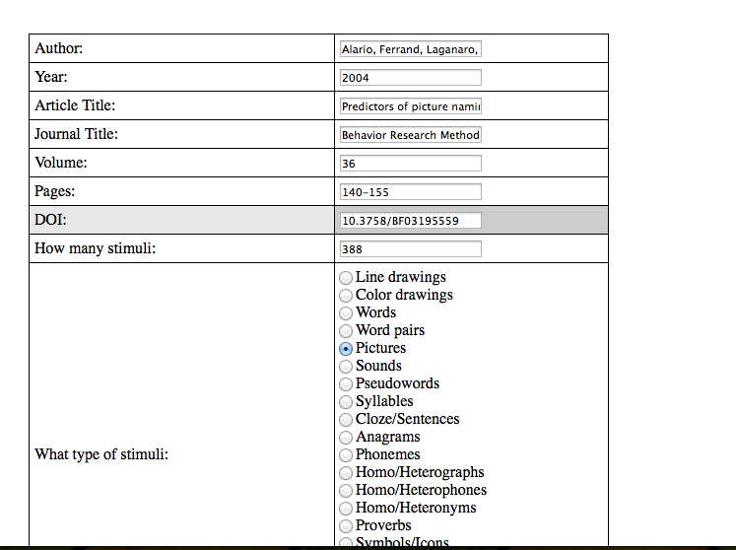

An example of the report error screen.

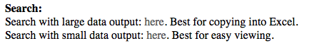

There are also two ways to search the LAB. When searching with the large data you will receive output that contains the same information as the large dataset. When searching with the small data you will receive output that contains the same information as the small dataset.

First, pick a type of stimuli:

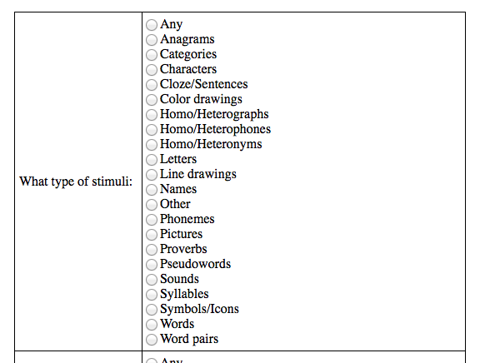

Selecting ANY will give you all of the options listed.

Then, select a language:

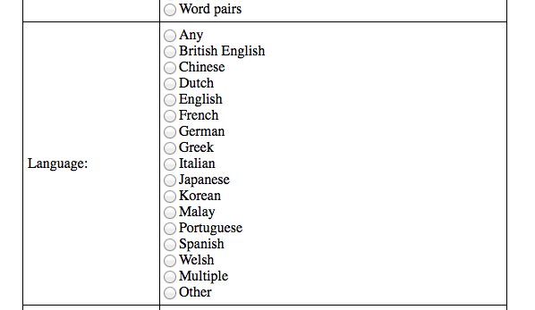

Then select a type of tag search:

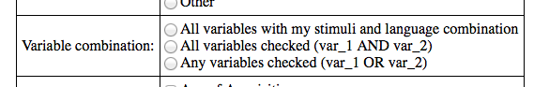

Options:

1. All the variables with my stimuli and language combination: will give you all of the possible tags with your stimuli/language selections. This option is akin to getting all tags.
2. All variables checked: will give you the combinations of stimuli, language, and all tags selected. Please note that this search may return no values if it is very specific (i.e. more than 5 tags, especially in languages other then English).
3. Any variables checked: will give you the combination of your different variables with your stimuli and language selection. For example, if you select words, English, frequency, and association, you will get all word stimuli in English with *either* frequency or association tags. The second option will give you frequency *and* association for the same article.

Lastly, select your keyword tags, if necessary:

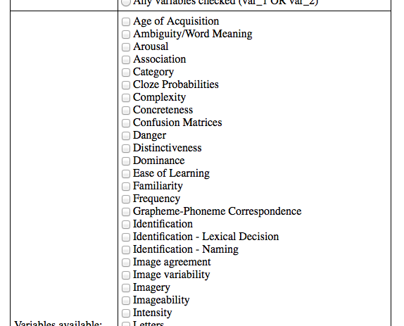

The descriptions of these can be found in the manuscript or on the homepage. The two search options are the same, but they will give you different forms of output depending on if you want large or small table formats.

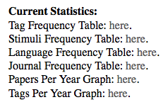

For your convenience and easy viewing we have created tables summarizing the tag, stimuli, language, and journal frequency in the LAB, as well as graphs of frequency of papers across years, and the frequency of tags across years. These tables and graphs are linked to the LAB and automatically updates as information is added to the LAB.

For example, each individual keyword tag can be used to create a graph under tags per year:

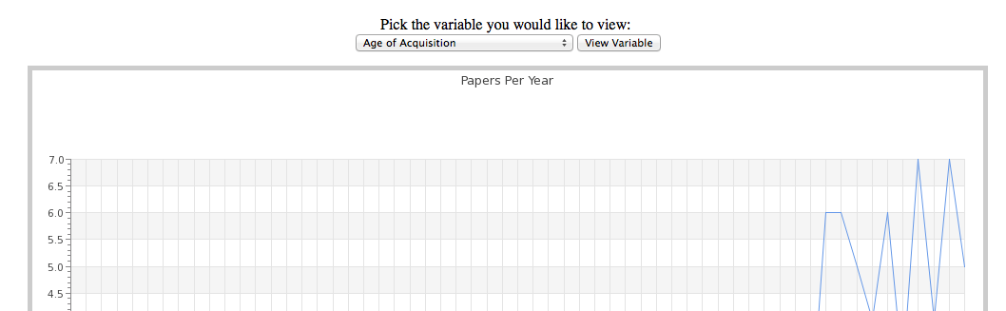

*Note*. The Age of Acquisition is the preset option that displays if you have not picked a variable.

# Untitled:Users:buchanan:Downloads:graph_tags.php.png

Graph of frequency tag. You can right click on any graph to download the image files.

# About

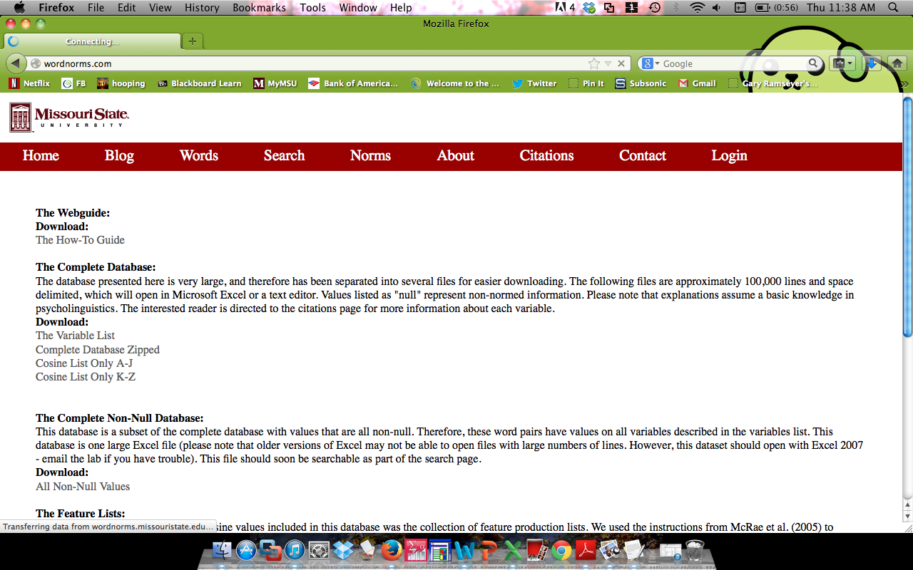

This page contains all the information and downloadable content for the project. You can download the entire database (all variables), just the cosine values (cosine lists), the variable explanation page, and the feature lists used to create cosine values. The manuscript and link to Behavior Research Methods are also provided.

# Citations

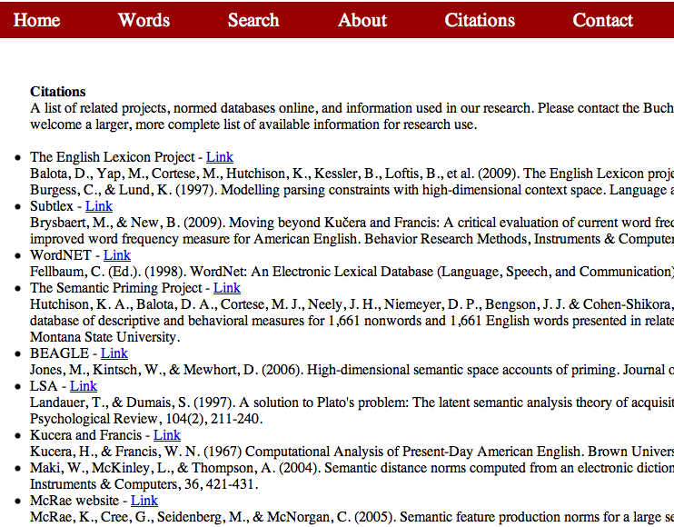

This page provides links to other databases, experimenter websites, and important articles in the creation of this database. Other links are welcomed (please contact [erinbuchanan@missouristate.edu](mailto:erinbuchanan@missouristate.edu)).

# Contact

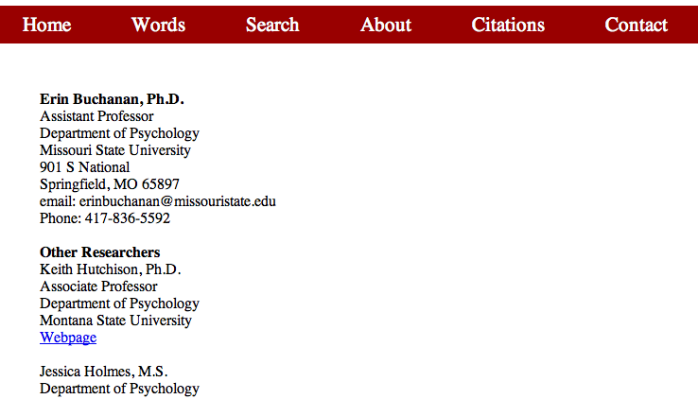

Lastly, contact information is provided for researchers involved in this project.